**The Growth of Orlando as an International Destination**

**Introduction**

It is no secret that tourism is the lifeblood of Florida’s economy. The industry directly employees over a million people and contributes over $51billion to state GDP (Florida TaxWatch Center for Competitive Florda, 2013). And, why shouldn’t it? The state is home to 8 of the top 20 amusement parks in North America, has 1,350 miles of coast (Beaver, 2006), and is home to more cruise ships than any other state (Florida TaxWatch Center for Competitive Florda, 2013). Tourism has enabled Florida to be one of seven states with no income tax (Kahn, 2015), 23% of all tax revenue collected is collected through sales taxes paid by tourists (Visit Florida, 2016). The importance of tourism to the state’s economy forces the question: “How do we measure the state’s attractiveness as a tourist destination?” As the state’s economy depends so heavily upon generating tourism, its ability to measure and forecast its ability to draw in tourists is essential to state planning – not just for governments but for local businesses as well.

This paper uses data collected by the Bureau of Transportation Statistics on Florida’s four major hub airports: Orlando International Airport (MCO), Miami International Airport (MIA), Fort Lauderdale-Hollywood International Airport (FLL), and Tampa International Airport (TPA). The data consisted of passengers disembarking at each respective airport, broken down by origin (domestic or international) and gathered monthly. After reviewing all twelve sets, international passengers landing at MCO was selected to be further investigated. Orlando is “a significant area with a significant reach” (Werley, 2015), and home to many tourist destinations, making it a good proxy for the state as a whole. International Passengers were selected because they represent the most resistant group to change. Due to the stress, cost, and inconvenience of international travel, any change that motivates an increase in international visitors is likely to create a simultaneous and greater increase in domestic visitors; visitors who’s trip to the state isn’t plagued by the frustrations of customs, currency exchanges, and language barriers.

**Background & Data Review**

Before 1981, upon landing in Orlando, passengers were dropped off outside a Quonset hut and asked to pick up their bags on the curb (Kassab, 2006). At that point Disneyworld was 10 years old and only four airlines made stops in Orlando. But airline de-regulation and the increasing popularity of Disneyworld forced the city to construct a new airport (Brew, 1980). Today, the airport is the 11th busiest in the nation, seeing 17,000 flights arrive in January 2017 alone (Bureau of Transportation Statistics, 2017). The airport is the considered to be the DOT’s 13th largest gateway to the world, with over 3.5 million international passengers arriving and departing in 2013, 82% of which were foreigners visiting the state (Office of the Assistant Secretary for Aviation and International Affairs, 2013). And don’t think it’s done growing yet, either. In 2015, the New York Times reported that “efforts made to attract foreign carriers…have paid off” (Mouawad, 2016). Later that year, Emirates airline launched daily flights between Dubai and Orlando, and the Vice-President of US sales said that “[Emirates is] convinced Orlando has an undersupply in connection” (Werley, 2015). More recently, Air Berlin announced more flights between Germany and Orlando (aero.de, 2016).

MCO is considered a large hub by the FAA, meaning that it takes in over 1% of total annual airline passengers (Federal Aviation Administration, 2016). Comparing it to Florida’s other three major hubs gives a sense to its scale. Figure 1 depicts total passengers landing at each airport. The data shows MCO battling with MIA to lead the state, with FLL just edging out TPA.

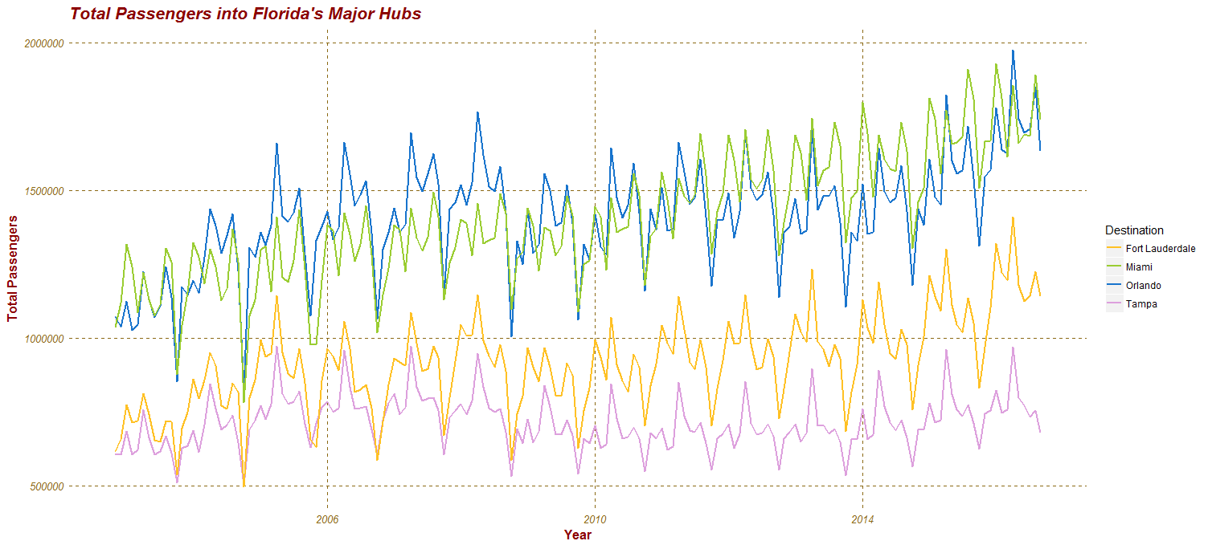

*Figure 1*

*Figure 2*

This figure only gives a surface view of the airports, however. Total passengers can be broken down into International and Domestic Passengers based on their airport of origin. Looking at the major hubs in terms of only International Passengers allows us, in conjunction with figure 1, to know where their passengers are coming from. Figure 2 clearly shows MIA vastly outpacing its

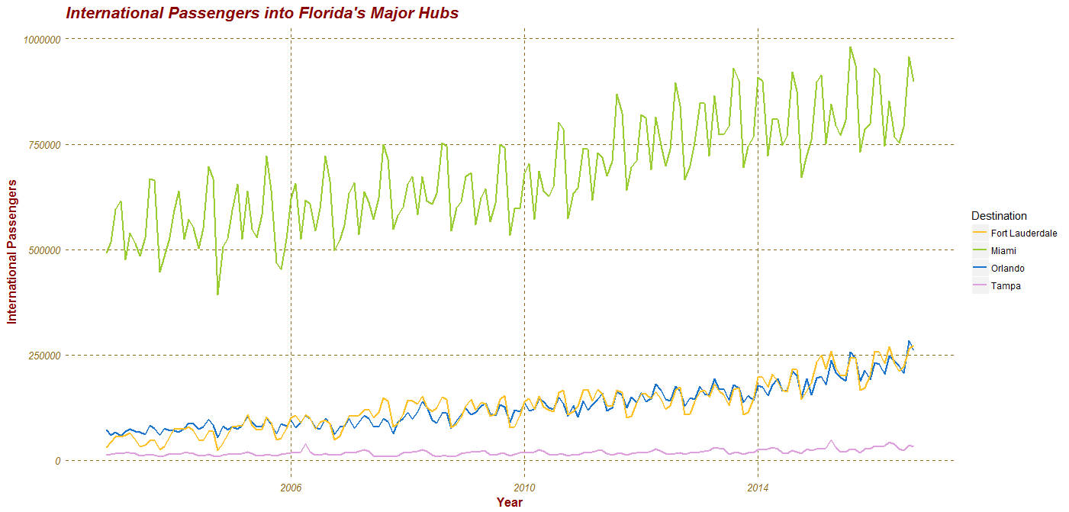

competitors, with MCO and FLL neck and neck for a distant second. This implies that most of MCO’s deplaned passengers are Domestic, more evidence of this will be seen later. Beyond raw counts, it is also useful to look at the consistency of an airports passenger numbers. Figure 3 displays violin plots depicting the distributions of each airports total passengers counts. We can see a wide range in the counts for MCO and MIA, with TPA looking rather round with the least amount of variation. We can also see that MCO is significantly more bell shaped than MIA, and skewed towards larger numbers. If we take the same idea and apply it to just International Passengers we get Figure 4, a collection of histograms describing the distribution of each airports International Passengers. In figure 4 we can see that Miami might take in many more foreign passengers, but it does so with a large variation (Not represented here, but backed up in the data is the impact of spring break on MIA. The spikes that are evident in Figure 2 are typically the March data points). Tampa is in the rear with a remarkable consistency. Orlando sits squarely in the center, a trait that contributed to it being the focal point of this paper.

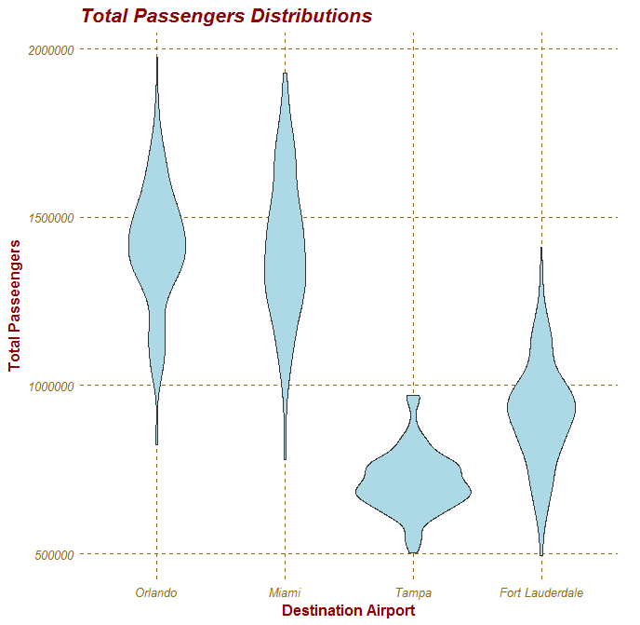

*Figure 3*

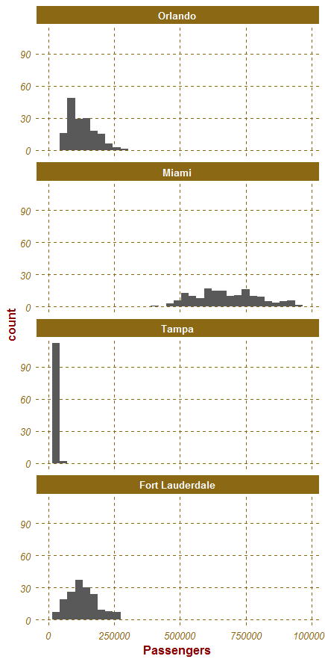

*Figure 4*

*Figure 5*

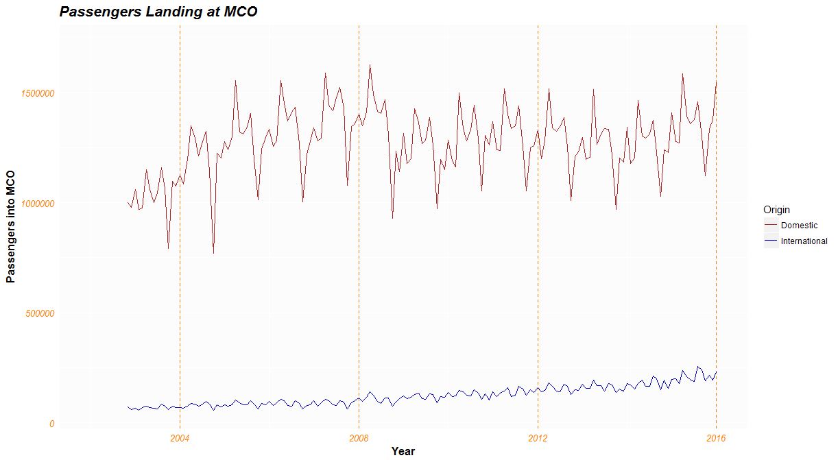

**Building a Model**

It has already been said that International Passengers make sense to forecast because represent a truer indication of the state’s progress in marketing itself, but there are mathematical justifications for this as well. Figure 5 details MCO Domestic Passengers and International Passengers over time. A violin plot or histogram is unnecessary to see that the Domestic Passengers dataset has a much larger variance than International Passengers. This large variance was a contributing factor in selecting International Passengers to model. Forecasts could be made more accurately with the latter. A second mathematical justification is evidenced in figures 6 and 7. Figure 6 displays a scatter plot with both Domestic and International Passengers plotted against a one period time lag. Again, the variance of the Domestic Passengers works against it, to form a much weaker relationship. Figure 7 excludes Domestic Passengers and just plots International Passengers with a lag, as well as a Loess Curve and its associated 95% confidence interval. We can see a strong relationship, but also the beginnings of some heteroskedasticity that plagues the model.

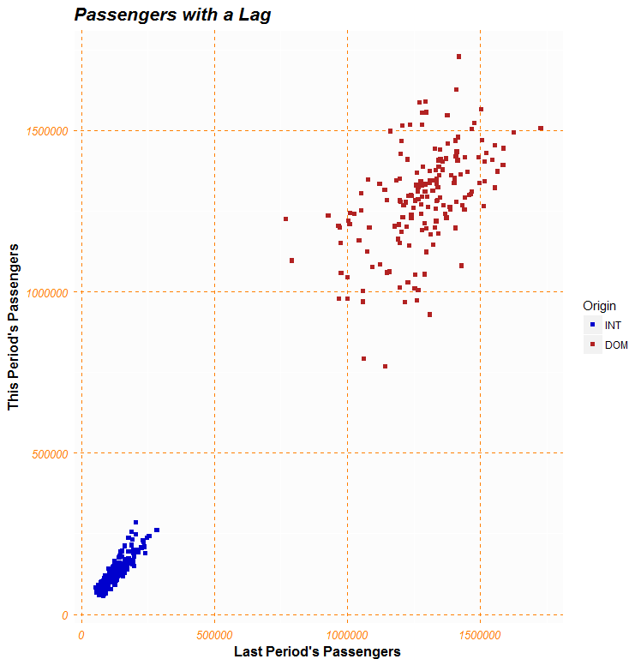

*Figure 6*

*Figure 7*

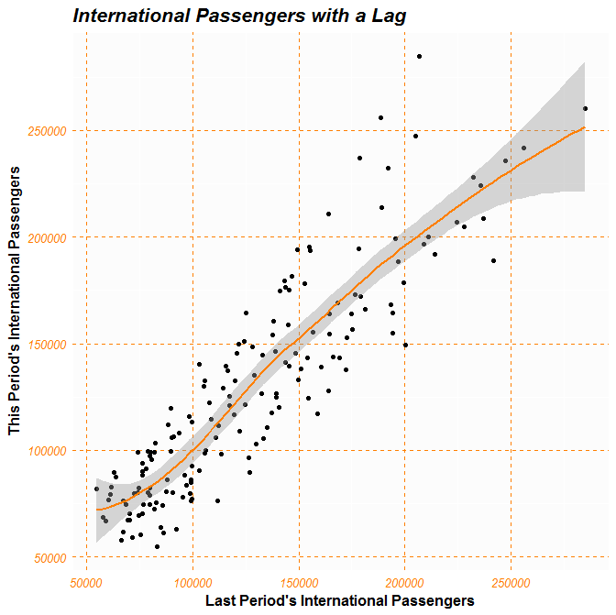

Finally, confident in our subject selection, we can move on to actual modeling. Figure 8 contains the subject, International Passengers landing at MCO displayed over time. We can see the evident uptrend, as well as obvious non-stationarity. Preforming an Augmented Dickey-Fuller test confirms this, yielding a p-value of 0.99 and pushing the decision to difference the model. The second transformation was done based figure 9. The heatmap of the differenced data exhibits clear seasonality. The horizontal bars represent months while vertical columns represent years. The pattern of horizontal striping betrays its seasonality. Taking both the first difference then the seasonal difference gives us a stationary dataset, with an ADF p-value of 0.01. This transformed dataset can be seen in figure 10 on the next page, and exhibits the second sign of heteroskedasticity. A log transformation fixes this issue, but gives a significantly weaker model in the end – one that fails the Ljung-Box test and contains many insignificant coefficients – so the log transformation was removed and we are stomaching the increased variance.

Now that the data is stationary we can look at its autocorrelations. Figure 11 displays the EACF for this data. With red X’s representing significant correlations at that lag, we can select a model whose terms match the upper-most vertex of a triangle of O’s. Here, this is an MA(1) process that describes a first-differenced, seasonally differenced model, giving us the preliminary model of ARIMA(0,1,1)X(0,1,1)12. With this framework in mind, we can calculate

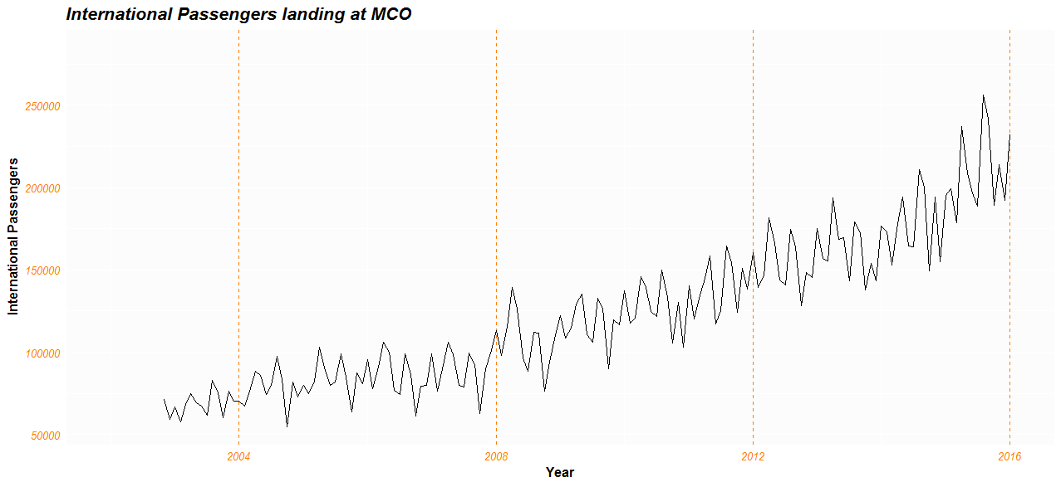

*Figure 8*

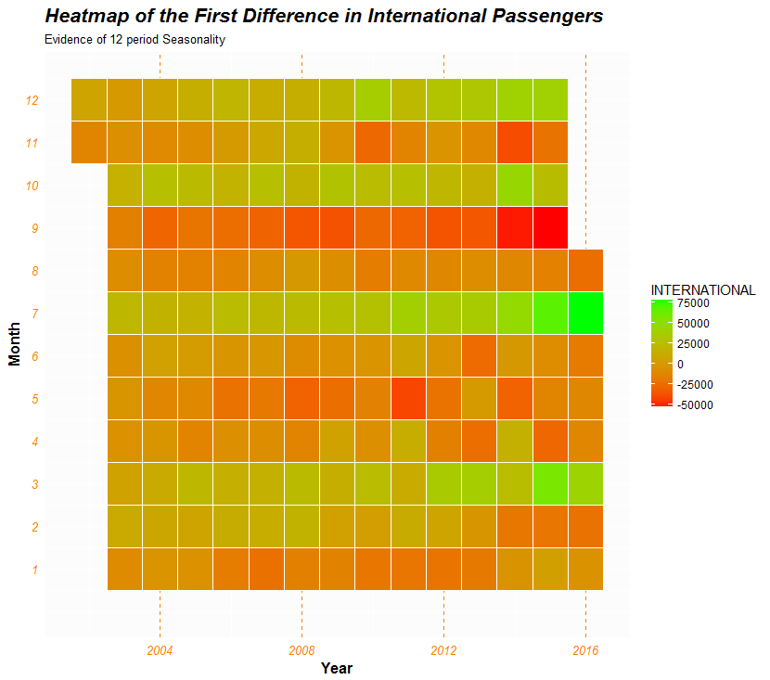

*Figure 9*

$θ_{1} = 0.6698$

$Θ_{1} =0.441$

Giving the model:

$$Y_{t}= Y_{t-1}+ Y_{t-12}- Y_{t-13}+ e_{t}+0.6698e_{t-1}+0.441e_{t-12}+0.2954e_{t-13}$$

The first observation to make about this model is its parsimony. Only two coefficients are used to the sequence, both of which are significant at the 5% level. The remaining terms are for differencing and seasonal adjustment. This model also contains a lower variance, AIC, and BIC than competing models. Figure 12 on the next page contains the Diagnostic Chart for the model.

*Figure 10*

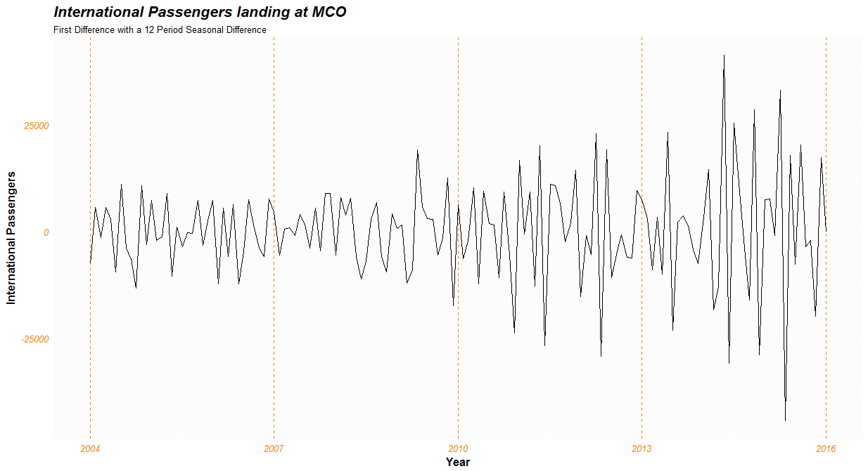

From it, we can see that it passes the Ljung-Box text and contains no significant residual autocorrelation. We do see some slight heteroskedasticity in the residuals, but this is to be expected, as we see it in our data. Figure 13 is the normal Q-Q Plot for the residuals. It is a bit of an oddity, not quite holding to the curve we’d like to see. A Shapiro-Wilks test was conducted to test this further, and it came back indicating that the population distribution is normal. In order to further reinforce this result, Figure 14 was created, depicting a histogram of standardized residuals. It looks normal enough to suggest that perhaps the Q-Q Plot is capturing an effect of the increasing variance, and not an assumption violating distribution, which is good because I prefer to violate my assumptions one at a time.

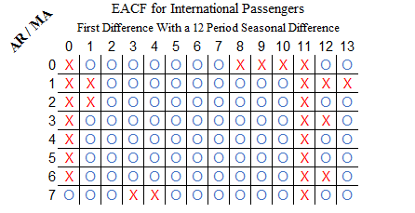

*Figure 11*

Figure 15 displays a 5-year forecast based on this model. The orange bands represent the high and low points in 2016. From this figure, we can clearly see that the variance gets away from us, but we can still interpret the results with ease. Even if we cling to the lower prediction limit, we can still maintain higher passenger counts than we had at the lowest point in 2016. In the best-case scenario, we can double our 2016 max by 2022.

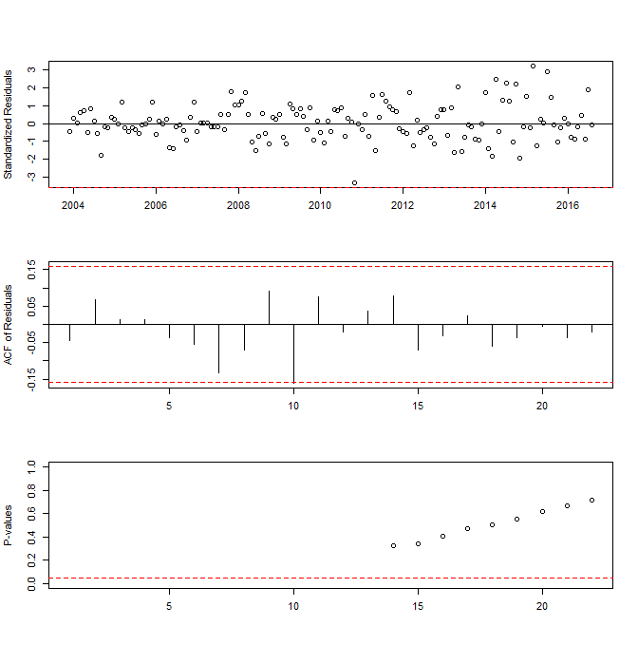

*Figure 12*

**Limitations & Conclusion**

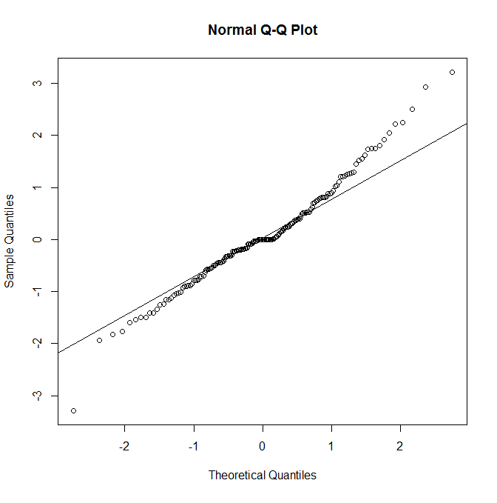

*Figure 13*

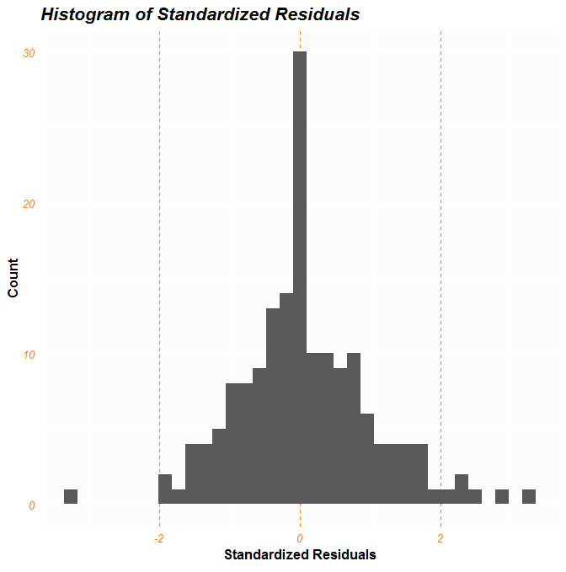

*Figure 14*

The primary limitation of the model is the runaway variance. It is recommended to attempt a model that useful with heteroskedastic data, such as a GARCH, when performing future studies. Perhaps looking at TPA might give a model with a more stable variance, but in this authors opinion, such a model would have less interpretive ease, as Tampa is less representative of the state. The second limitation is its lack of economic indicators as additional predictors. Many factors affect Tourism besides the previous period’s tourism; by including the US Dollar Index or perhaps a dummy system to capture the effects of culture, you could build a more thorough, albeit less parsimonious, model to capture the growth of tourism.

*Figure 15*

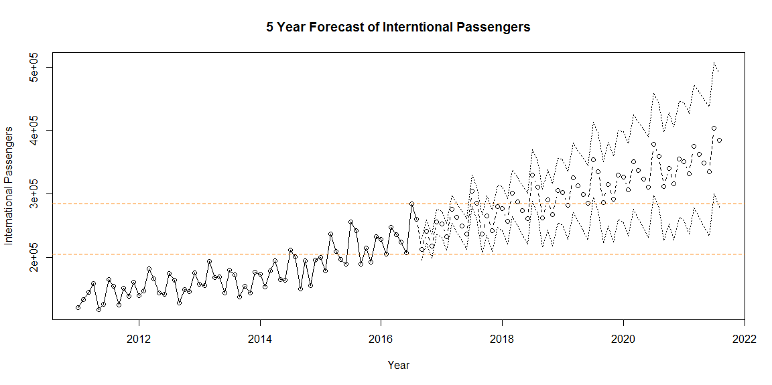

International Passengers landing at Orlando International Airport seems like a roundabout way to measure the growth of Central Florida tourism, but it’s really about measuring, and forecasting, more than just tourism. It’s a representation of desirability. International air travel is complicated, stressful, expensive process to endure for a vacation; for people to put up with it just to visit Orlando means that Orlando must be worth the hassle in their eyes. Assuming regulations are to stay constant, growth in this subgroup of tourism can be expected to correspond to growth across all subgroups. Domestic Passengers, on the other hand, have the benefit of convenience, that can confound any conclusions we reach about the state’s growth as a desirable destination. Pursuing a strategy of growing tourism by growing International Passengers is to grow tourism in a way that has a higher upper bound than growing domestic passengers (more people live out of the country than in it), and will likely attract additional domestic passengers at the same time. It is for this reason that this analysis was conducted. As we see International Passengers grow, we know that the attractiveness of the state as a tourist destination must be increasing.

# **Works Cited**

aero.de. (2016, August 2). *Air Berlin mit deutlich mehr USA-Flügen im Sommer 2017.* Retrieved from aero.de: http://www.aero.de/news-24697/Air-Berlin-mit-deutlich-mehr-USA-Fluegen-im-Sommer-2017.html

Beaver, J. C. (2006). *US International BordersL Brief Facts.* Washington DC: Knowledge Services Gorup.

Brew, T. (1980, January 20). Orlando's $250 Million Airport. *Sarasota Herald-Tribune*, p. 51.

Bureau of Transportation Statistics. (2017, February). *Orlando, FL: Orlando International (MCO)*. Retrieved from Bureau of Transportation Statistics: https://www.transtats.bts.gov/airports.asp?pn=1&Airport=MCO&carrier=FACTS

Bureaur of Transportation Statistics. (2016, October). *Passengers All Carriers - Orlando, FL: Orlando International (Destination Airport)*. Retrieved from Bureaur of Transportation Statistics: https://www.transtats.bts.gov/Data_Elements.aspx?Data=1

Federal Aviation Administration. (2016, March 3). *Airport Categories*. Retrieved from faa.gov: https://www.faa.gov/airports/planning_capacity/passenger_allcargo_stats/categories/

Florida TaxWatch Center for Competitive Florda. (2013). *Investing in Tourism.* Tallahassee: Florida TaxWatch. Retrieved from http://floridataxwatch.org/resources/pdf/2013TourismFINAL.pdf

Florida TaxWatch Center For Tourism. (2003). *The Impact of Tourism on Florida's Economy: Telling the Full Story.* Tallahassee: FSU Center for Economic Forecasting and Analysis. Retrieved from http://www.cefa.fsu.edu/content/download/47182/327651/file/florida_tourism03.pdf

Kahn, C. (2015, January 13). *State with no income tax: Better or Worse?* Retrieved from Bankrate: http://www.bankrate.com/finance/taxes/state-with-no-income-tax-better-or-worse-2.aspx

Kassab, B. (2006, May 26). Original terminal reduced to rubble. *Orlando Sentinel*.

Kock, M. G. (2007, May). PROPOSING AN ALTERNATIVE FRAMEWORK FOR FEASIBILITY STUDIES FOR LARGE PUBLIC TOURISM INVESTMENTS: A QUANTITATIVE ANALYSIS OF THE ORANGE COUNTY CONVENTION CENTER. Orlando, Florida, The United States of America. Retrieved from http://etd.fcla.edu/CF/CFE0001629/kock_gerald_200705_mast.pdf

Mouawad, J. (2016, March 16). Expansion by Midwest Airlines Sets Off a Skirmish in the U.S. *The New York Times*.

Office of the Assistant Secretary for Aviation and International Affairs. (2013, June). *U.S. International Air Passenger and Freight Statistics.* Retrieved from dot.gov: https://web.archive.org/web/20140110215449/http://www.dot.gov/sites/dot.dev/files/docs/US%20International%20Air%20Passenger%20and%20Freight%20Statistics%20Report%20for%20June%202013.pdf

Visit Florida. (2016). *Tourism Fast Facts*. Retrieved from VisitFlorida.org: http://www.visitflorida.org/about-us/what-we-do/tourism-fast-facts/

Werley, J. (2015, June 2). *Private pods, five course meals: Why Emirates' Orlando service will bring high-end flying to Jacksonville travelers.* Retrieved from Jacksonville Business Journals: http://www.bizjournals.com/jacksonville/news/2015/06/02/private-pods-five-course-meals-why-emirates.html